Team Member
Handbook

Table of Contents
Welcome/Team Requirements | 3
Our Purpose | 4
Kids Ministry Pillars | 4
Serving Opportunities | 5
Curriculum Information | 6-7
Service Commitment & Guidelines | 8
Time Matters | 9
Sample Schedules | 10
Be Present | 11-12
Creating a Safe Place | 13
Respect the Process | 14
Fun Matters | 15
Wellness/Firearms Policy | 16
Appropriate Affection | 17
Scheduling | 18
Safety/Emergencies | 24

Welcome

Dear Team Member,
Thank you so much for joining the Next Level Kids Team! We cannot begin to tell you how thankful and excited we are for you to join our family!

Each weekend, we reach hundreds of children in an exciting and active environment filled with passionate worship, energetic games, great Bible stories and relational small groups that teach God’s values at an age-appropriate level.

Our weekend services meet at the same time as our adult services, and are specifically designed for children from birth through fifth grade. While parents are experiencing the life-giving worship and teaching of Next Level Church’s main services, we are giving their children the exact same experience in Next Level Kids.

Through your gifts, talents, and faithfulness, let’s partner together to make a real change in this world by empowering the future generation. Your investment of time and energy is valuable and we are thankful for you! As a Team Member, you have the opportunity to deeply influence the life and future of a child and his understanding of and relationship with Jesus.

Becoming a volunteer is easy. Becoming a Next Level Kids Team Member requires some time and energy. Your kids have great potential to be leaders and world changers in the Kingdom of God. And, God has called you into one of the most influential roles in their lives.

Excited to do life and ministry with you,

Next Level Kids Staff

NLC Kids Team Requirements

We ask each team member to:
- Complete the Empowerment Track offered through Next Steps
- Complete a Kids Application and Background Check.
- Commit to Attend One Service, Serve One Service each week.
- Read the Kids Team Handbook thoroughly and complete Kids training.
- Register for and actively respond to the scheduling system (CCB)

Our Purpose
We exist to partner with parents in leading their children to become FULLY ENGAGED followers of Jesus!

Six Pillars

Safe Places
We create safe and clean spaces for children to learn and explore their faith with grace and love. This means that we are strategic about our environments and team member training to create safety for every child.

Family Partnerships
We view everything that we do as an opportunity to team up with parents in order to help raise children with a strong spiritual foundation and a strong moral foundation as well.

Specialized Environments
Each of our different environments have different curriculum, music, and events that are designed to be age (phase) relevant, fun and engaging for each child.

Consistent Relationships
This means that each child will be exposed to a lot of the same teachers, small group leaders and other children which will produce excitement about coming and comfort once they arrive.

Biblical Focus
This means that everything that we do will be focused around teaching children biblical truths and showing them how to live out those truths as they walk through life.

Fun and Engaging Experiences
We want children to grow up loving church! We place our attention to experiences, activities and lessons that will be enjoyable and memorable for children. We want them to be excited about coming back.

Serving Opportunities in Kids Ministry
Take 2 Leader- to lead students (K-5th grade) that are here for more than one service in a safe and loving environment that continues to encourage their spiritual growth and nurture their love for church through FUN and Creativity.
Host/ Storyteller- to support the Studio K or K Town (K-5th grade) mission by teaching students about the monthly theme and bottom line through creative, interactive teaching of biblically based history and truths.
Production Team- to support the Studio K or K Town mission by enhancing the flow of service and bible story through sound, lighting, videos, and computer slides.
Pre-K Team Member- to create a safe and loving place where 2 through 5-year-olds can experience the love of God through engaging lessons from the Bible so that they know 1) God Made Me, 2) God Loves Me, 3) Jesus wants to be my friend forever. Note: Only women 14 and above approved by the Kids Director may serve in the 2-year-old’s room. Age 11 and above male or female may serve in the 3-5’s room with an adult female in each room. Only adult women 18 and older may hold children and change diapers.
Nursery: Babies & Ones Team Member –create a safe and loving place where babies and one-year-olds can experience the love of God through embracing care. Note: Only women 14 and above approved by the Kids Director may serve in Babies and Ones rooms. Only adult women 18 and older may hold children and change diapers.
K Town/Studio K Small Group Leader (SGL)- weekly, consistent leaders who help children (k-5th grade) make wise choices, trust God no matter what, and treat others the way they want to be treated. We believe “real life change happens in the context of small groups.” Our goal is for a small group to be highly relational. A small group leader is one of the most important, if not the most important role in Kids. This is why we ask our small group leaders for a commitment to serve weekly. It is vital for a child to develop a relationship with their leader and be able to confide in them. Consistency in serving makes this possible.
Worship Motions Leader- to support the Studio K or K Town mission by leading students into a time of exciting and meaningful worship.
Experience Team Member- responsible for greeting families and children at the doors with a warm smile, checking the children into our database and escorting families to the correct classes.

Babies- 5 years

The love and care nursery and preschool leaders provide gives infants and preschoolers their first impressions of our loving God. The lessons we teach from the Orange: First Look curriculum incite WONDER about God and His Creation and are based on these three simple, but powerful, truths.

God Made Me
“For you created my inmost being; you knit me together in my mother’s womb. I praise you because I am fearfully and wonderfully made; your works are wonderful, I know that full well.” - Psalm 139:13-14

God Loves Me
“For I am convinced that neither death nor life, neither angels nor demons, neither the present nor the future, nor any powers, neither height nor depth, nor anything else in all creation, will be able to separate us from the love of God that is in Christ Jesus our Lord.” - Romans 8:38-39

Jesus Wants to Be My Friend Forever
“For God so loved the world that he gave his one and only Son, that whoever believes in him shall not perish but have eternal life.” - John 3:16

Each month, we focus on one Bible Story, One Memory Verse, and one
Bottom Line.

E L E M E N T A R Y

The lessons we teach from Orange: 252Basics provoke DISCOVERY of who God is and what he’s doing in the heart of each child. And, we want every kid to know and understand these three basic, but powerful, truths modeled by Jesus Luke 2:52 “Jesus grew in wisdom and stature, and in favor with God and men.”

FAITH: I can trust God no matter what. Encourage kids toward what is good and what is right before you critique them for what is wrong and what is bad.
• trust and follow Jesus.
• spend time getting to know God.

So I will

• do whatever God says.
• discover God’s plan for my life.

WISDOM: I need to make the right choice. Encourage kids toward what is good and what is right before you critique them for what is wrong and what is bad.
• He is my Creator.
• He is my Father.

Because

• He is my Guide.
• He is my Savior.

FRIENDSHIP: I should treat others the way
I want to be treated.
Encourage kids toward what is good and what is right before you critique them for what is wrong and what is bad.
• Show God’s love to those around me
• Care enough to put others before me

So I will

• Respect whoever God puts over me
• Be the right friend to those beside me
Service Commitment
The best way to create trust and show children you truly care is to create consistency.
Always remember how important you are in these children's lives - no one can replace or fill in who you are to a child.
Your relationship with a child matters a ton! We believe the greatest gift we can give a parent is to give their child a consistent adult and a group of friends they can do life with. For this reason, we ask that Next Level Kids Team Members serve on a weekly basis for a minimum of a one school year commitment.
Next Level Kids Team Arrival and Check-in
Arrive 45 minutes early. Team members should arrive forty-five minutes prior to the service time they are scheduled to serve for pre-service Cleaning and Huddle. If you are unable to serve during your scheduled service time, due to illness or emergency, please contact your Serve Team Coach or Administrative Coordinator. Whenever possible, please try to find a replacement to be sure our classrooms are fully staffed.

Nametags. All Kids Team Members wear a yellow security nametag. It helps our Experience and Safety Teams clearly identify background checked Team Members, and it is a great way for parents to identify who is serving. Please check in, print your security name tag and secure it to your shirt as soon as you arrive to serve.
During the Training process, Shadowing Team Members will be issued a lanyard to wear until you have been completely trained and cleared to serve.

Important Guidelines
No Picture Policy. Please refrain from taking pictures of children. No pictures should be taken and stored on devices, or posted to any website or social media outlet.
No peanut products are allowed in Next Level Kids due to potential allergies.
Dress code
Please be modest and neat in your appearance. Jeans or long pants with a Next Level Kids tee shirt are encouraged. Please make sure dresses are knee length. Due to the active nature of Kids Ministry, please avoid short skirts and dresses or low cut shirts. Shorts should have at least a 3 inch seam.

Restroom Procedures
Adults are not permitted in the restrooms with children, except when necessary, such as an accident or with potty training. Under this circumstance, an adult female team member over 18 must assist the child (with the door open) or another adult present. Men are not permitted to take a child into the restroom.
TIME MATTERS
Time is precious and we have so little of it so let’s…

Make Time for What’s Important.

Faith. We make no apologies for encouraging families to make time in their weekly schedule for church and conversations about faith. Serving should never take the place of attending church and/or growing in your own faith... it should only help you to grow in your faith! We never look more like Jesus than when we are serving.

Family. We know the family calendar can get a little crazy with work, school, and everyone’s sports and activities. The church doesn’t need to add to the chaos by pulling the family apart at diﬀerent times of the week. As much as possible, try to make Attend One, Serve One a family affair!

Friendship. We believe that God designed us to be in community with others. We’re also convinced that life change happens best in the context of relationships. Next Level Kids is based on the foundation of real, faith building relationships with other kids and adult leaders. That’s why we make time for small groups. So, we’re asking you to make time for your small group of kids and for friendships with other leaders that are serving in Kids. Our Kids Ministry Teams are teams of people that have a common interest….KIDS! Make it a priority to get to know one another as you serve together.

Make the Best of the Time We Have.
As a church, we only have about 40 hours a year to influence kids compared to the approximately 3000 hours a year that parents have. So, that reminds us that parents have the primary spiritual influence in a child’s life and our job is to support them. This is why we Partner with Parents.
When we count the hours we have, we make the hours we have count. That’s why we put so much energy into our weekly experiences and craft every minute of our time together. For your kids, life happens daily. For your group, life happens weekly. When you miss your weekly, you miss out on 7 daily’s. To put this in perspective, if you get 40 hours of influence a year compared to the 3000 hours of influence their parents have, then you missing one weekly gathering is like a parent missing 75 hours or 9 days' worth of time with their kids.

Please take a look at the sample schedule below, making note
of the arrival times for each class.

Studio K

- 45 min Prior – Arrival/Cleaning
- 30 min Prior- Team Huddle
- 20 min Prior – Kids Check in begins
- Preservice activity
- Large Group Game
- Worship
- Large Group Teaching
- Small Groups

K Town

- 45 min Prior – Arrival/Cleaning
- 30 min Prior- Team Huddle
- 20 min Prior – Kids Check in
- begins
- Preservice activity
- Large Group Game
- Worship
- Large Group Teaching
- Small Groups

Pre- K
- 45 min Prior– Arrival/Cleaning
- 30 min Prior- Team Huddle
- 20 min Prior – Kids Check in begins
- Preservice activity
- Worship
- Bible Story
- Crafts/Activities

Velocity Each weekend service
BE PRESENT

The Apostle Paul modeled this well when he wrote to the Thessalonians,

So we cared for you. Because we loved you so much, we were delighted to share with you not only the gospel of God but our lives as well. - 1 Thessalonians 2:8

As a Small Group Leader, your role is more than showing up for a program and leading an activity or a discussion with some kids about the bible. Your role is to share with them not only the gospel but also your lives, as well.

To prove to your few that you love them … that you care for them … that you’re genuinely present in their lives … you have to …

SHOW UP PREDICTABLY

Healthy community is built on consistent relationships. If you’re consistent, reliable, predictable, you’ll win the trust of your few. For your you and your kids, life happens daily. For your group, life happens weekly. When you miss your weekly, you miss out on 7 daily’s. To put this in perspective, if you get 40 hours of influence a year compared to the 3000 hours of influence their parents have, then you missing one weekly gathering is like a parent missing
75 hours or 9 day’s worth of time with their kids.

without a without a

1 Day SGL = 9 Days PARENT
SHOW UP MENTALLY
It’s one thing to show up physically. It’s an entirely diﬀerent thing to show up physically AND mentally. We all know what it’s like to be in a room or even in a conversation with someone who isn’t REALLY there with you. When you’re with your few be fully present. To show up mentally, you have to be prepared, awake, engaged.

TO FULLY ENGAGE WITH YOU NEED TO DISENGAGE FROM

YOUR FEW
from your work (leave thoughts of work in your car, don’t take work-related texts/calls)

from your your family (make arrangements necessary for your family prior to being with your group)

from your friends (no clumping, you can talk with your friends another time)

When you show up

FAITHFULLY
You demonstrate THE FAITHFULNESS OF GOD

Create a Safe Place for Them
First of all, you have to be a safe person and help keep them safe from harm in as much as you have within your power. For more on what it means to be a safe person and to keep them from harm, please read through this entire handbook.
As you get to know your kids, you’ll inevitably experience tension in some way. They might ask a hard question. There might be conflict between a couple of kids in the group. Someone might reveal something that’s hard to hear. There may be behavior issues. So, to help you create a safe place, here’s a few important notes:

FOLLOW THIS PROCESS FOR BEHAVIOR MANAGEMENT

REQUEST

Be clear about what you’re asking of them.

RESET

Move them, sit by them, rearrange them.

REMOVE

Take them out of the group for a private conversation.

RELEASE
There may be times when you must release the child
to their parents

And, finally … never, ever, ever shame or embarrass a kid in private
or in front of their peers.
RESPECT THE PROCESS
Every kid is at a diﬀerent place in their Journey with Jesus. They’re also
moving forward at diﬀerent paces. Some kids have very diﬃcult family lives at
home. Some kids have some pretty significant intellectual hang ups with faith. Other kids have experienced trauma or even abuse.

You might be able to answer some questions––but not all. You might be able to help them out a bind or two––but not every time. Therefore, your primary job is simply to walk with them on this journey––encouraging them as they take each step forward.

GUARDING THE HEART

As you develop trust and create a safe place, kids will reveal to you some very
diﬃcult things. In those situations, you’ll have to quickly discern if what is
being revealed is okay for the group or if it should be discussed in a private conversation. Furthermore, you have to be clear on this important principle:

You can NEVER promise COMPLETE confidentiality.

You can let your few know that they can trust you…that you won’t gossip…
and that you will do your best to make the wise decision. But if it is one of the
3 HURTS you will have to talk with the director or pastor. Don’t try to handle any of these alone.

THE “3 HUR TS”
physically, se xually, emotionally

1. Being Hurt
2. Hurting Others
3. Hurting Themselves

If you observe behaviors and or signs that may indicate a child is being maltreated physically, emotionally and/or sexually, notify your Next Level Kids staff member immediately.

FUN MATTERS.

Having FUN convinces kids you actually like them. It reconnects what has been disconnected, fosters resilience, and authenticates forgiveness. Fun
helps friendships go deep. Honestly, one of the most eﬀective ways to connect with
your kids is to have a lot of fun with them!

KIDS WERE CREATED WITH A DESIRE FOR FUN WE ALL ARE CREATED WITH A DESIRE FOR FUN

SO LIGHTEN UP LAUGH TOGETHER

Have Fun

LOOSEN UP. There’s no need to feel like you have to get through every question or point in the lesson every time. Relax, joke around a little. Just don't use sarcasm or teasing as a source of humor. Kids don't get it. They take you literally and it can be hurtful.

LEARN WHAT THEY LIKE. Find out what their favorite shows and movies are; what their favorite sports are; what they like to talk about. Pay attention to what lights up their face.

Creating Fun

We work pretty hard at creating a fun environment. That’s why we have so many
kids who love to come. It’s fun! Worship along with your kids! Get down on the
carpets and participate in the activities! Join with us and help out.

We all love to have fun, to be with fun people, and to be in fun places.

Let's be those people. Let’s be that place.

Wellness Policy for Children and
Team Members
To ensure the health of the other children and Team Members, we ask that sick children and Team Members not attend any childcare event. It is recommended to not attend church if any of the following symptoms are present:
- A fever of 100 degrees of higher
- Diarrhea or vomiting— no matter what the cause. (i.e. medication, teething, etc.)
- Any symptom of childhood diseases such as Scarlet Fever, German Measles, Mumps, Chicken Pox, or Whooping Cough
- Sore throat, constant cough, or croup
- Colored mucous (runny nose that is not clear; in the eyes)
- Any unexplained rash
- Any skin infection: boils, ringworm, impetigo, or any open sores that leak fluid/blood
- Pinkeye, redness of the eyes, or any other eye infection
- Any communicable disease
- Lice— including the presence of eggs or nits

Please continue to follow these precautions when choosing to attend any in-person gathering:
- No fever, cough, sore throat, body aches or other cold/flu symptoms.
- No contact with anyone that has COVID-19 within 14 days

If you have any of these symptoms, please stay home from your scheduled time to serve. If you suspect a child is sick during a service, please contact a staff member and they will contact the family if needed. All children and Team Members must be symptom-free without medication for 24 hours straight before returning to the Next Level Kids area.
When it is known that children have been exposed to an illness that is easily transferable, parents and Team Members in the exposure area will be advised.
Firearms
Next Level Church considers your safety and the safety of our children to be of the upmost importance. As part of that effort, Team Members in Next Generation environments or in a Next Generation program (Next Level Kids, Collide etc.) may NOT be in possession of firearms while actively serving. "Actively serving" can be defined as times you are actively engaged in serving responsibilities, whether scheduled or not. It does not apply to times you are simply attending a service at Next Level Church.
This does not apply to active or retired law enforcement officers carrying firearms under that authority or to members of the Safety Team that have been specifically authorized by the Executive Operations Pastor or Safety Director.
Appropriate Affection for Next Level Kids

To ensure respect, safety, and appropriate boundaries of the Kids environments the following are guiding principles for physical contact between ministry leaders and children. *Updated for COVID-19
Love and affection are a part of church life and ministry. There are many ways to demonstrate age and developmentally appropriate affection while maintaining positive and safe boundaries with children and youth. Examples of positive and appropriate forms of affection include:
- “Air hugs”
- Pats on the shoulder or back
- “Air” High-fives and fist taps
- Verbal praise
- Sitting beside small children

The following forms of affection are considered inappropriate with children in ministry:
- Lengthy embraces
- Kisses
- Holding children over three years old on the lap
- Touching of any area covered by a bathing suit other than for appropriate diapering or toileting of infants and toddlers
- Showing affection in isolated areas
- Touching legs
- Wrestling
- Tickling, piggyback rides, or massages
- Any form of unwanted affection

*Please no hugging, holding hands, or high fives in this season.
Accessing Scheduling in Next Level Connect
Team members can access scheduling through Next Level Connect from their phones without an app. The following tips should help them access what they need easily.
Responding to Scheduling Invitations
- Confirm your email and phone number on the Next Level connect system.
  - Please confirm your correct current email and phone number at registration or with your
Next Level Church staff team point of connection.
- Confirm that you can log in to the Next Level connect system.
HTTP://connect.nextlevelchurch.com

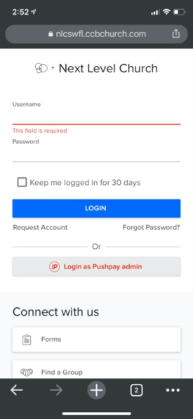
  - Login page looks like this….please use your email address as your username.
  - Should you need to reset your password, please use the reset password button
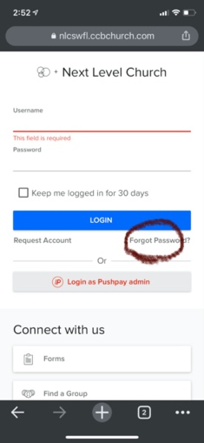
  - If you have any trouble with your login, please send an email to chris.denney@nextlevelchurch.com and we will get you logged back in.

THREE OPTIONS TO ACCEPT/CONFIRM SERVING REQUESTS
OPTION 1: IF ENABLED IN YOUR PROFILE, SYSTEM WILL TEXT YOU A NOTIFICATION OF A SERVING REQUEST.
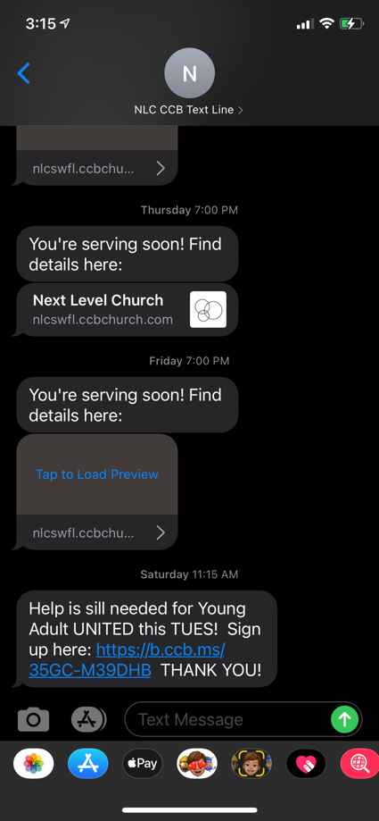
OPTION 2: AN EMAIL TO YOUR INBOX (MAKE SURE YOU ADD CCB EMAILS TO YOUR FOCUSED INBOX…SOMETIMES THEY’LL GO TO YOUR CLUTTER/JUNKMAIL BOX)
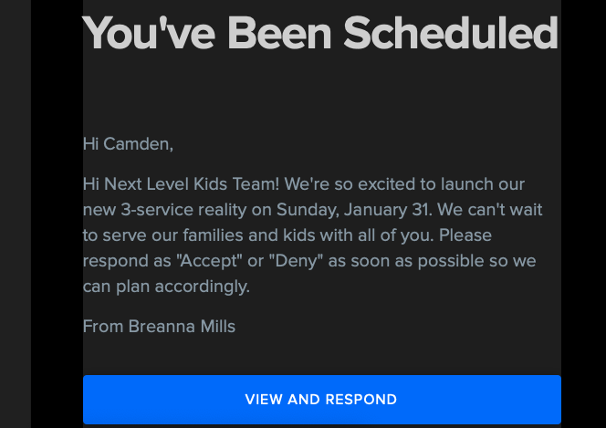

OPTION 3: VIA THE NEXT LEVEL CONNECT SYSTEM.
- 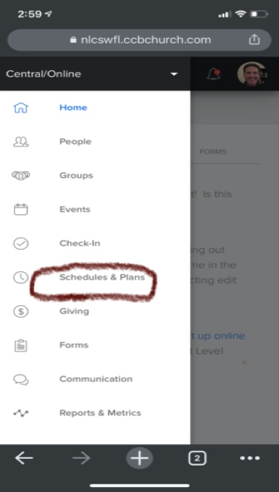
Find the option that says schedules and plans.

- Select the button that says “MY SERVING”
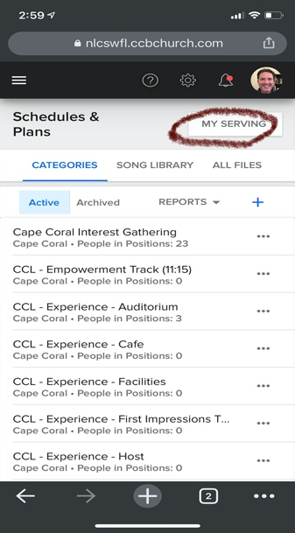

- FIND THE OPTIONS THAT LIST YOUR NAME WITH A DATE AND A PENDING LABEL ON THEM. TOUCH THAT YELLOW BUTTON
. 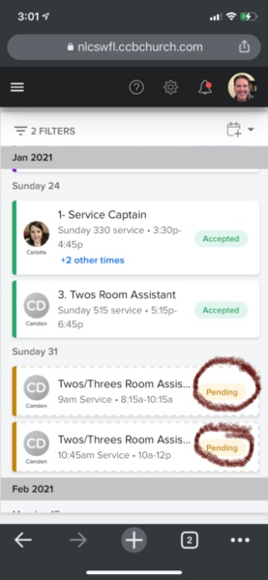
- 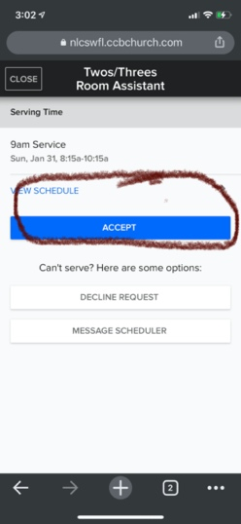
CLICK ACCEPT.
- IF YOU NEED TO DECLINE A SCHEDULE REQUEST OR COMMUNICATE WITH THE SCHEDULER, THERE ARE OPTIONS FOR THIS AS WELL.
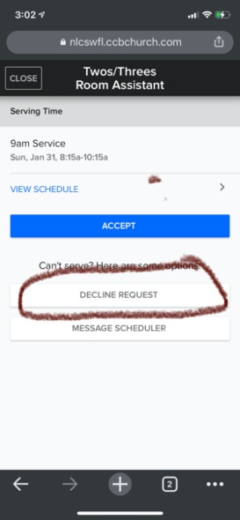
- 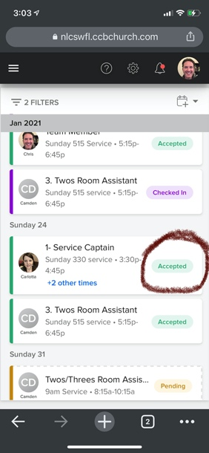
NOTICE THAT THE SCHEDULE WILL NOW SAY [ACCEPTED] AND TURN GREEN.
- ADDITIONAL OPTIONS NEXT PAGE
- 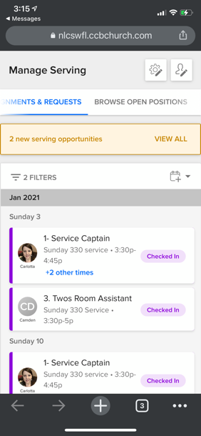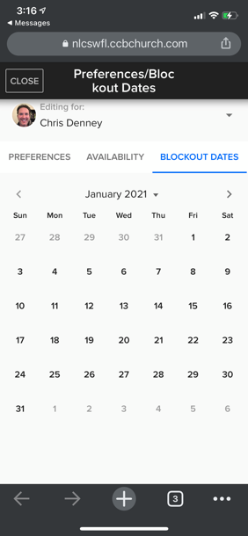
USING THE GEAR BUTTON WITH PENCIL OR THE PROFILE BUTTON (HEAD WITH PENCIL) AT THE TOP OF THIS SCREEN GIVES YOU THE FOLLOWING OPTIONS
- Serving Requests-by clicking this link, volunteers can see any requests that they have not yet accepted or declined.
- Accepted Requests- from this link, volunteers can see what they are scheduled to serve and can access service plans
- Edit My Contact Info-this option will allow volunteers to confirm/change their email, phone and carrier information
- Preferences/Availability-this is the link that will allow them to put in blackout dates to adjust availability.
- In ORDER to receive text message schedule notifications, please edit profile info and enter your MOBILE CARRIER.

If a volunteer cannot log in or does not know their login information:

- A staff member must open the individual’s profile in Next Level Connect.
- At the top of the profile, there is a button labeled ACTIONS.
- When you click on ACTIONS, there is a drop down menu. Click on Username/Password.
- From there you can edit their username and password information. **NOTE** Their username email and contact email do not have to be the same.
- Once the new/edited information is saved, they can immediately use it to log in to their profile.

